Final Project – (200 Points Total):

This is an extremely detail oriented assignment! Please spend the time necessary to complete this assignment as thoroughly as you possibly can since it will be most beneficial to you in the long run!

There are a number of topics on here. You may need to research certain topics and others you may have within your class notes from the labs and lectures. For each topic, you should provide a detailed description and/or explanation of what the topic is (in your own words). Following the description/explanation you will create an example topology that will be used for this question. (Yes, you may utilize this same topology on other questions – only if it directly relates to other questions.) Make sure you specify interfaces in use, ip addresses and subnet masks within your topology. Next, you will provide a configuration for the topic listed based upon your example topology. For the first few questions, you should provide detailed steps as to where you are within the router or switch when issuing a specific command so you demonstrate basic knowledge and manipulation of the Cisco IOS. Throughout all of the topics you should specify what each command does. (A brief example is listed below.) After you have finished the topic configuration you should provide any show commands that would verify the configuration for that specific topic. Following the show commands, specify how you would test the topic configuration (possibly via specific debug commands, etc…). Please keep in mind… No assumptions are made! Some of the items have multiple steps so be sure to include **all** the steps in the configuration, etc...

**For example:**

If you are asked to ***assign an IP Address to a router interface***, you may want to specify the following:

Create a sample topology, then write…

An IP Address is a Layer 3 logical address that is assigned to each host within a TCP/IP network. The IP Address assigned to the host is determined by the network administrator and is dependent upon the network it is directly connected to. An IP Address is a hierarchical address that consists of 4 octets, 8 bits each, 32 bits in total. An IP Address is typically written in dotted decimal notation:

* + - 1. is an example of a Class A IP Address

To assign an IP Address to a router interface you would proceed in the following manner:

|  |  |
| --- | --- |
| Router> | This prompt specifies the router is in USER mode |
| Router>***enable*** | this command is entered to go from USER mode to PRIVILEGE mode |
| Router# | You are now in PRIVILEGE mode |
| Router# ***configure terminal*** | used to enter GLOBAL CONFIGURATION mode from PRIVILEGE mode. This is needed to configure all parameters within the router |
| Router(config)# | You are now in GLOBAL CONFIGURATION mode |
| Router(config)#***interface fastethernet0/0*** | This is entered to go into INTERFACE CONFIGURATION mode to configure the fastethernet0/0 interface within the router |
| Router(config-if)# | You are now in INTERFACE CONFIGURATION mode |
| Router(config-if)#***ip address 1.1.1.1 255.0.0.0*** | This sets the IP Address to 1.1.1.1 with a subnet mask of 255.0.0.0 which is the default subnet mask for a Class A IP Address |
| Router(config-if)#***no shutdown*** | After the IP Address is set on the interface, it’s always a good idea to enable the interface and test connectivity. |

Specify the show commands, test commands to verify the configuration is working properly and move onto the next topic.

This assignment should be **printed and turned in by 4:00pm Friday, May 02, 2014.** When submitting this assignment *you may either place it under my office door or place it in my mailbox on the 3rd floor of the Hancock Center.*  **In addition to your printed copy, please submit a softcopy in Microsoft Word (.docx or .doc) format via ilearn.** Make sure you cite your resources and do not plagiarize! **All work should be completed individually!!!** **There will not be any extensions given for this assignment**, so make sure you **SUBMIT IT ON TIME otherwise you will receive a grade of ZERO!!!**

If you have any questions or concerns, please let me know!

Topics to research, explain, provide detail and provide examples for: (make sure you provide as much detail as possible in a concise manner and make it as legible as possible! Once this is graded and turned back to you, it will provide you with a detailed study guide for your final practical.) Please feel free to copy and paste the table from above and use it as a template for each question. Please do not remove the point values, numbers or questions/statements below. Use this as a template and add your answers under each numbered question/statement on each page.

# Research Syntax Exam – (200 Points Total)

*(10 points)*

1. Cabling: Rollover cable, straight-through cable, and crossover cable (NOTE: make sure you specify the pin-outs, color code, use, etc…)

***Rollover Cable*** is used to connect a computer terminal to a router’s console port. The cable is flat and has a light blue color.

|  |  |
| --- | --- |
| **Connector A** | **Connector B** |
| Pin 1 (Orange/White) | Pin 8 (Purple) |
| Pin 2 (Orange) | Pin 7 (Purple/White) |
| Pin 3 (Green/White) | Pin 6 (Green) |
| Pin 4 (Blue) | Pin 5 (Blue/White) |
| Pin 5 (Blue/White) | Pin 4 (Blue) |
| Pin 6 (Green) | Pin 3 (Green/White) |
| Pin 7 (Purple/White) | Pin 2 (Orange) |
| Pin 8 (Purple) | Pin 1 (Orange/White) |

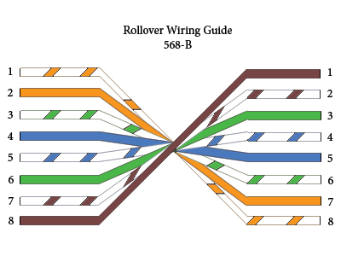

***Straight-Through Cable*** is a twisted pair copper wire cable for LAN use and the RJ-45 connectors at either end have the same pinout configuration. The main use of this cable is to connect computers and other end-user devices.

|  |  |
| --- | --- |
| **Connector A** | **Connector B** |
| Pin 1 (Orange/White) | Pin 1 (Orange/White) |
| Pin 2 (Orange) | Pin 2 (Orange) |
| Pin 3 (Green/White) | Pin 3 (Green/White) |
| Pin 4 (Blue) | Pin 4 (Blue) |
| Pin 5 (Blue/White) | Pin 5 (Blue/White) |
| Pin 6 (Green) | Pin 6 (Green) |
| Pin 7 (Purple/White) | Pin 7 (Purple/White) |
| Pin 8 (Purple) | Pin 8 (Purple) |

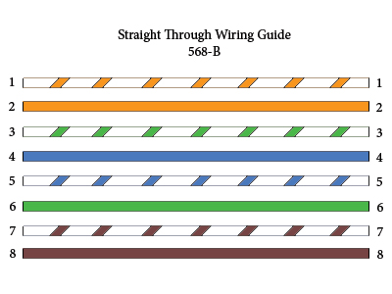

***Crossover Cable*** are more commonly used when connecting a computer directly to another computer, switch directly to another switch, or router directly to another router.

|  |  |
| --- | --- |
| **Connector A** | **Connector B** |
| Pin 1 (Orange/White) | Pin 3 (Green/White) |
| Pin 2 (Orange) | Pin 6 (Green) |
| Pin 3 (Green/White) | Pin 1 (Orange/White) |
| Pin 4 (Blue) | Pin 7 (Purple/White) |
| Pin 5 (Blue/White) | Pin 8 (Purple) |
| Pin 6 (Green) | Pin 2 (Orange) |
| Pin 7 (Purple/White) | Pin 4 (Blue) |
| Pin 8 (Purple) | Pin 5 (Blue/White) |

*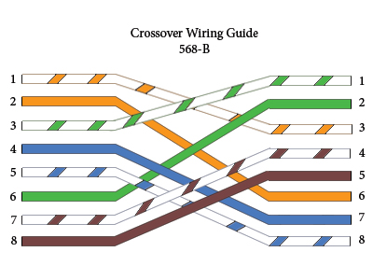(10 points)*

1. Basic router configuration (NOTE: hostname, ip addresses, passwords for each mode of the router or switch, enabling interfaces, etc…)

|  |  |
| --- | --- |
| Router>enable | Enters PRIVILEGED mode |
| Router# configure terminal | Enters GLOBAL CONFIGURATION mode |
| Router(config)#hostname RouterA | Sets the router name to RouterA. |
| Router(config)#no ip domain-lookup | Turns off name resolution on unrecognized commands (spelling mistakes). |
| Router(config)#enable password cisco | Set the password for the router to “cisco” |
| RouterA(config)#line console 0 | Enters LINE CONSOLE mode. |
| RouterA(config-line)#logging synchronous | Commands will not be interrupted by unsolicited messages. |
| RouterA(config-line)#line vty 0 4 | Moves to virtual Telnet lines 0 through 4. |
| RouterA(config-line)#password cisco | Sets the line console password to “cisco” |
| RouterA(config-line)#login | Enables password checking at login. |
| RouterA(config-line)#exit | Moves from LINE CONSOLE mode to GLOBAL CONFIGURATION mode. |
| RouterA(config)#interface fastethernet 0/0 | Moves to interface Fast Ethernet 0/0 configuration mode. |
| RouterA(config-if)#ip address 172.16.10.1 255.255.255.0 | Assigns an IP address and subnet mask to the Fast Ethernet 0/0 interface. |
| RouterA(config-if)#no shutdown | Turns the Fast Ethernet 0/0 interface on. |
| RouterA(config-if)#interface serial 0/0/0 | Moves directly from the Fast Ethernet (0/0) interface to the Serial (0/0/0) interface. |
| RouterA(config-if)#ip address 172.16.20.1 255.255.255.252 | Assigns an IP address and subnet mask to the Serial 0/0/0 interface. |
| RouterA(config-if)#no shutdown | Turns the Serial 0/0/0 interface on. |
| RouterA(config-if)#exit | Moves from LINE CONSOLE mode to GLOBAL CONFIGURATION mode. |
| RouterA(config)#exit | Moves from GLOBAL CONFIGURATION mode to PRIVILEGED mode. |

*(10 points)*

1. Telnet, ping, traceroute (write a paragraph for each, create one topology and make sure you articulate how these utilities are utilized, what underlying protocols are used, etc…)

**Telnet** enables users to log into remote systems and user resources as if they were connected to a local system. It is a terminal-emulated application layer protocol in the TCP/IP protocol stack.

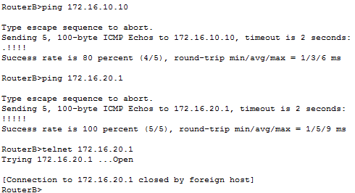

**Ping** is an Internet Control Message Protocol (ICMP) which echo’s a message and its reply. Pings are used to test the connect-ability throughout the entire network and establish where problems may lay.

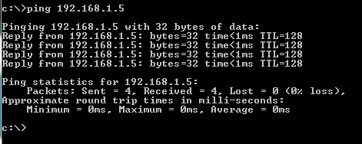

**Traceroute** is used to display all of the hops/routes that are used to reach the destination xxx.xxx.xxx.xxx by entering in Router#traceroute xxx.xxx.xxx.xxx

*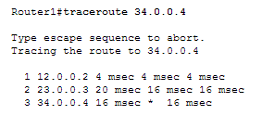(10 points)*

1. STP and the use of portfast (Make sure you specify this for Cisco 2960 and 3560 series switches since this is what we are using this semester in the lab.)

**Spanning Tree Protocol** (STP) is a layer 2 protocol that works with switches and its main purpose is to ensure that you do not create loops when there are redundant paths in the network. This usually happens when there are two or more routers and switches in a network configuration. To begin you need to select a switch to be the root of the spanning tree. When loops are detected, the STP algorithm shuts down the interface, effectively preventing the loop from occurring. If the best path becomes unavailable, STP then recalculates the network and finds the next best route.

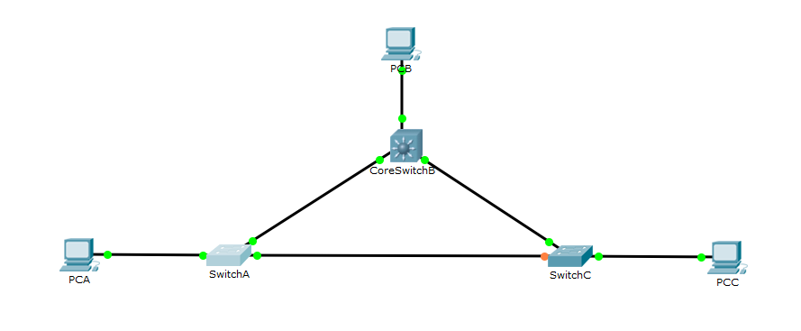

Without any manual configuration, the switches above automatically defaulted to PVST mode and disabled any connections which created a loop.

|  |  |
| --- | --- |
| !  spanning-tree mode pvst  !  Interface fastethernet 0/1  Switchport mode access  Spanning-tree portfast  !  Interface fastethernet 0/2  Switchport mode access  Spanning-tree portfast  ! |  |

*(10 points)*

1. VTP with 802.1q (NOTE: Make sure you accomplish this without going into VLAN Database mode and show the syntax for both 2960 and 3560 switches!)

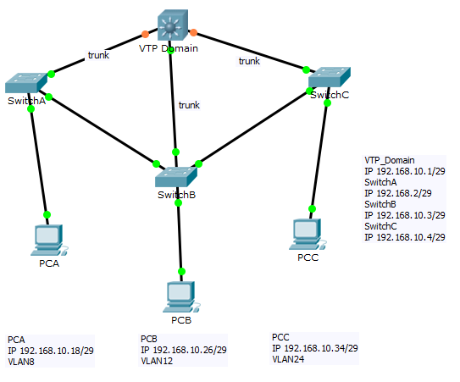

|  |  |
| --- | --- |
| VTP_Domain(config)#hostname VTP_Domain | Changes the hostname to VTP_Domain |
| VTP_Domain(config)#vtp mode server |  |
| VTP_Domain(config)#vtp domain Awesome | Sets the domain to Awesome |
| VTP_Domain(config)#vtp password cisco | Creates a password “cisco” |
| VTP_Domain(config)#vlan 8 | Names vlan8 |
| VTP_Domain(config-vlan)#name EIGHT | Same thing |
| VTP_Domain(config-vlan)#vlan 12 | Names vlan12 |
| VTP_Domain(config-vlan)#name TWELVE | Same thing |
| VTP_Domain(config-vlan)#vlan 24 | Names vlan24 |
| VTP_Domain(config-vlan)#name TWENTYFOUR | Same thing |
| VTP_Domain(config-vlan)#interface f0/4 | Enters configuration for interface fastethernet 0/4 |
| VTP_Domain(config-if)#switchport mode access | Enters switchport mode access |
| VTP_Domain(config-if)#int range f0/1 – 3 | Enters cofig for fa0/1 through fa0/3 |
| VTP_Domain(config-if-range)#switchport trunk encapsulation dot1q | Starts trunk encapsulation dot1q |
| VTP_Domain(config-if-range)#int vlan1 | Enters config for vlan1 aka VTP domain |
| VTP_Domain(config-if)#ip address 192.168.10.1 255.255.255.248 | Sets the IP address and mask. |
| VTP_Domain(config-if)#no shutdown | Turns the interface/vlan on |
| VTP_Domain(config-if)#int vlan8 | Enters config for vlan 8 |
| VTP_Domain(config-if)#ip address 192.168.10.17 255.255.255.252 | Sets the IP and mask. |
| VTP_Domain(config-if)#no shutdown | Turns on the interface |
| VTP_Domain(config-if)#int vlan 12 | Enters config for int vlan12 |
| VTP_Domain(config-if)#ip address 192.168.10.25 255.255.255.252 | Sets the IP and mask |
| VTP_Domain(config-if)#no shutdown | Turns on the interface |
| VTP_Domain(config-if)#int vlan24 | Enters config for int vlan24 |
| VTP_Domain(config-if)#ip address 192.168.10.33 255.255.255.252 | Sets the IP and mask |
| VTP_Domain(config-if)#no shutdown*(10 points)* | Turns on the interface |
| **PCA** | **PCB** |
| *!*  *hostname PCA*  *!*  *vtp mode client*  *vtp domain PCA*  *vtp password cisco*  *!*  *interface f0/2*  *switchport mode trunk*  *!*  *interface f0/3*  *switchport mode trunk*  *!*  *interface f0/1*  *switchport mode access*  *switchport access vlan 8*  *spanning-tree portfast*  *!*  *!*  *interface vlan1*  *ip address 192.168.10.2 255.255.255.248*  *!*  *!*  *no shutdown*  *!*  *ip default gateway 192.168.10.1*  *!*  *!*  *!*  *end* | !  hostname PCB  !  vtp mode client  !  vtp domain PCB  vtp password cisco  !  !  interface f0/2  switchport mode trunk  !  interface f0/3  switchport mode trunk  !  interface f0/4  switchport mode trunk  !  interface f0/1  switchport mode access  switchport access vlan12  spanning-tree portfast |
| **PCC** | !  hostname PCC  !  vtp mode client  vtp domain PCC  vtp password cisco  !  int f0/2  switchport mode trunk  !  int f0/3  switchport mode trunk  !  int f0/4  switchport mode trunk  !  int f0/1  switchport mode access  switchport access vlan24  spanning-tree portfast  !  int vlan1  ip address 192.168.10.4 255.255.255.248  no shutdown  !  !  ip default gateway 192.168.10.1  !  !  !  end |

*(10 points)*

1. VLANs (NOTE: how to create one or more with names, assigning different interfaces to VLANs, etc… (Make sure you accomplish this without going into VLAN Database mode (this is the deprecated way of configuration for VLANs!) Make sure you setup an IP Address on the administrative VLAN.)

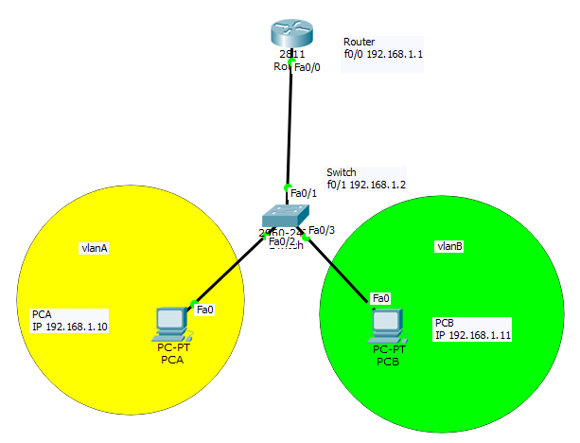

|  |  |
| --- | --- |
| Switch>enable | Enters privileged mode |
| Switch#configure terminal | Enters global configuration mode |
| Switch(config)# no ip domain-lookup |  |
| Switch(config)# line console 0 |  |
| Switch(config-line)#logging synchronous |  |
| Switch(config-line)#login |  |
| Switch(config-line)#password cisco |  |
| Switch(config-ling)#exec-timeout 0 0 |  |
| Switch(config-line)#line aux 0 |  |
| Switch(config-line)#login |  |
| Switch(config-line)#exit |  |
| Switch(config)#ip default-gateway 192.168.1.1 |  |
| Switch(config)#interface vlan1 |  |
| Switch(config)#ip address 192.168.1.2 255.255.255.0 | Sets “Router” as vlan1 |
| Switch(config)#no shutdown | Turns the interface on. |
| Switch(config)#interface fastethernet 0/1 | Enters the configuration for Fast Ethernet 0/1 |
| Switch(config-if)#description Link to Router | Description for F0/1 |
| Switch(config-if)#interface fastethernet 0/2 | Enters the configuration for Fast Ethernet 0/2 |
| Switch(config-if)#description PC-A | Description for F0/2 |
| Switch(config-if)#interface fastethernet 0/3 | Enters the configuration for Fast Ethernet 0/3 |
| Switch(config-if)#description PC-B | Description for F0/3 |
| Switch(config-if)#exit | Goes back to global configuration mode |
| Switch(config)#interface vlanA | Creates vlanA |
| Switch(config-if)#ip address |  |
|  |  |
|  |  |
|  |  |
|  |  |

*(10 points)*

1. Inter-VLAN routing

Inter-Vlan Routing is the capability to route traffic between vlans. This functionality could be on the Switch itself (for Layer 3 Switches), on another module or card on the switch (for modular switches) or even an external router.

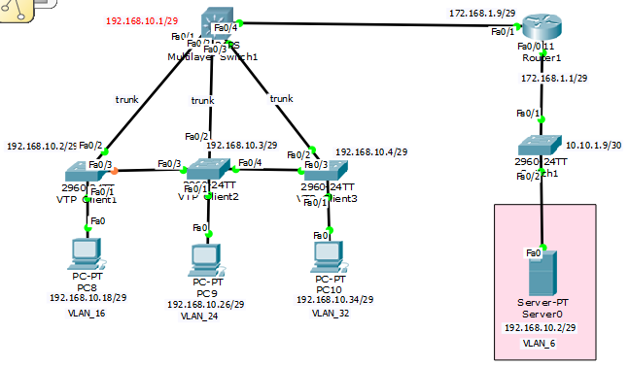

|  |  |
| --- | --- |
| **Router1** | **SwitchA** |
| !  hostname Router1  !  int f0/0  ip address 172.168.1.1 255.255.255.248  no shut  !  int f0/1  ip address 1721.68.1.9 255.255.255.248  no shut  !  int f0/0.1  encapsulation dot1q 1  ip address 172.168.1.9 255.255.255.248  !  int f0/0.6  encapsulation dot1q 1  ip address 192.168.10.2 255.255.255.248  !  int f0/0  no ip address  no shutdown  ! | !  hostname Switch1  !  vlan 6  name OOD  !  int f0/1  switchport mode trunk  !  int f0/2  switchport mode access  switchport access vlan 1  ip address 10.10.1.9 255.255.255.252  no shutodown  ! |

*(10 points)*

1. **Static routing (NOTE: With AND Without the use of a default static route.)**

Static Routing happens when routers/routing tables are manually configured. The IP addresses and masks are entered in by the system administrator which means the routes are fixed and do not change until the network is physically changed and must be reconfigured. The potential for input mistakes increases when the routes are manually entered in due to mistakes/typos.

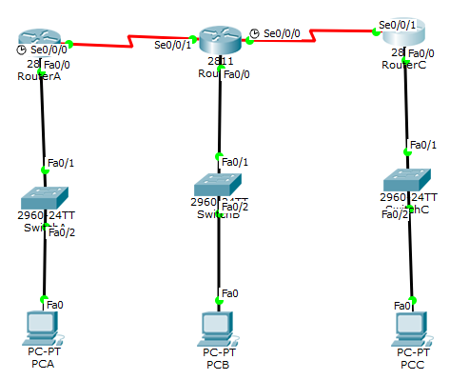

|  |  |
| --- | --- |
| Router>enable | Enters Privileged Mode |
| Router#configure terminal | Enters global configuration mode |
| Router(config)#hostname RouterB | Changes the name from router to RouterB |
| RouterB(config)#ip route 172.16.10.0 255.255.255.0 serial 0/0/1 | Sets the routed IP address and mask for int s0/0/1 |
| RouterB(config)#ip route 172.16.50.0 255.255.255.0 serial 0/0/0 | Sets the routed IP address and mask for int s0/0/0 |
| RouterB(config)#no shutdown | Turns on the interface. |
| RouterB(config)#int sserial 0/0/0 | Enters the configuration for interface s0/0/0 |
| RouterB(config-if)#ip address 172.16.40.1 255.255.255.0 | Sets the IP address and mask. |
| RouterB(config-if)#int sserial 0/0/1 | Enters configuration for interface s0/0/1 |
| RouterB(config-if)#ip address 172.16.20.2 255.255.255.0 | Sets the IP address and mask. |
| RouterB(config-if)#int fastethernet 0/0 | Enters the configuration for interface fastethernet 0/0 |
| RouterB(config-if)#ip address 172.16.30.1 255.255.255.0 | Enters the configuration for fastethernet 0/0 |
| RouterB(config-if)#no shutdown | Turns on the Fast Ethernet interface. |
| RouterB(config-if)#int serial 0/0/0 | Enters the configuration for serial 0/0/0 |
| RouterB(config-if)#no shutdown | Turns on the serial interface. |
| RouterB(config)#int serial 0/0/1 | Enters the configuration for serial 0/0/1 |
| RouterB(config-if)#ip address 172.16.20.2 255.255.255.0 | Sets the IP address and mask. |
| RouterB(config-if)#no shutdown | Turns on the serial interface. |
| RouterB(config-if)#int s0/0/0 | Enters the configuration for serial 0/0/0 |
| RouterB(config)#ip route 172.16.10.0 255.255.255.0 serial 0/0/1 | Sets the route ip & mask for serial 0/0/1 |
| RouterB(config)#ip route 172.16.50.0 255.255.255.0 serial 0/0/0 | Sets the route ip & mask for serial 0/0/0 |
| RouterB(config)#exit | Exit/End |
| +++++++++++++++++++++++++++++++++++++++++++ | +++++++++++++++++++++++++++++++++++++++++++++ |
| **Commands For RouterB** | **Commands For Router C** |
| !  hostname RouterB  !  ip route 172.16.10.0 255.255.255.0 serial 0/0/1  ip route 172.16.50.0 255.255.255.0 serial 0/0/0  !  !  interface serial 0/0/0  ip address 172.16.40.1 255.255.255.0  no shutdown  !  interface serial 0/0/1  ip address 172.16.20.2 255.255.255.0  no shutdown  !  interface fastethernet 0/0  ip address 172.16.30.1 255.255.255.0  no shutdown  !  ip route 172.16.10.0 255.255.255.0 serial 0/0/1  ip route 172.16.50.0 255.255.255.0 serial 0/0/0  !  !  !  !  end  ! | !  hostname RouterC  !  interface fastethernet 0/0  ip address 172.16.50.1 255.255.255.0  no shutdown  !  interface serial 0/0/1  ip address 172.16.40.2 255.255.255.0  no shutdown  !  !  ip route 0.0.0.0 0.0.0.0 serial 0/0/1  !  !  !  end  !  Router#ping 172.16.10.0  Type escape sequence to abort.  Sending 5, 100-byte ICMP Echos to 172.16.10.0, timeout is 2 seconds:  !!!!!  Success rate is 100 percent (5/5), round-trip min/avg/max = 2/13/24 ms |

*(10 points)*

1. **RIP and RIPv2**

RIP is the most commonly used version because it is compatible with all devices that are capable of RIP routing. It is a distance vector routing protocol that uses the hop count to figure out the best path from the source to the destination.

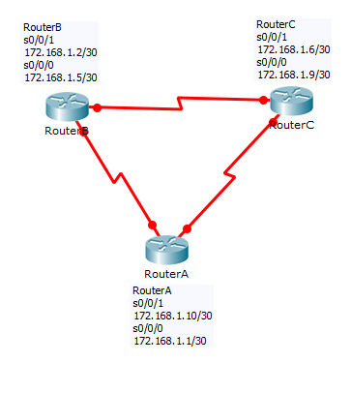

**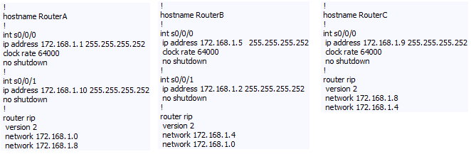***(10 points)*

1. **EIGRP (NOTE: Make sure you utilize VLSM in your topology and configuration without the use of automatic summarization.)**

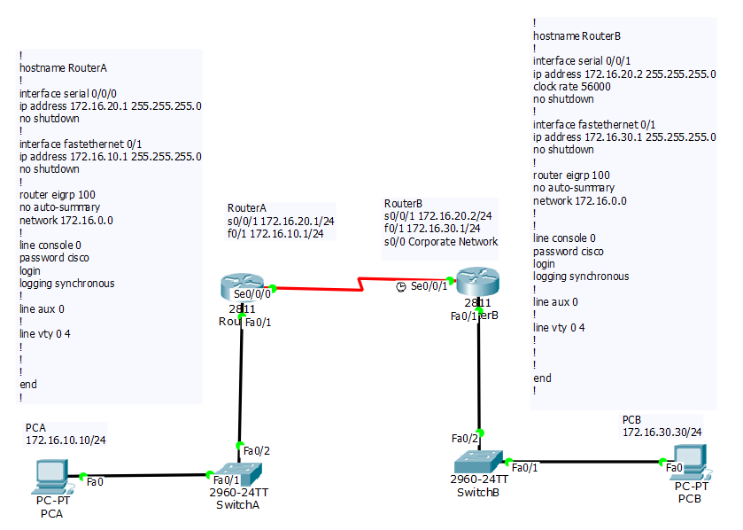**Enhanced Interior Gateway Routing Protocol** better known as EIGRP is a distance-vector routing protocol that helps automate routing configurations and decisions. It is a proprietary protocol designed by Cisco Systems and is only available for Cisco equipment. The EIGRP protocol lets the routers connected in a network to share information that it knows about a neighboring network and it will only share information that the neighboring router does not have instead of sending over everything.

PCB can ping across the network to PCA

*(10 points)*

1. 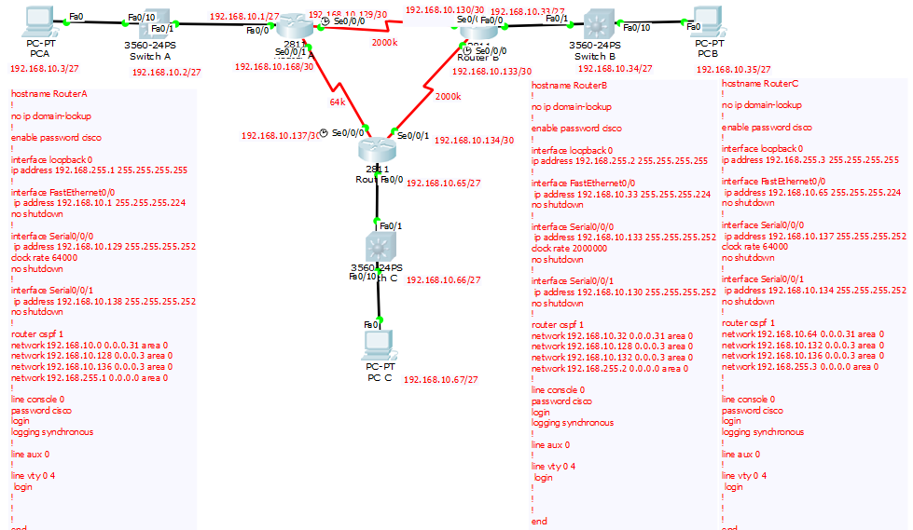**OSPF (NOTE: Make sure you utilize loopback interfaces within your topology and configuration…and make sure you specify why you are utilizing them.)**

Open Shortest Path First (OSPF) is a link-state routing protocol for Internet Protocol (IP) networks that use a link state routing algorithm and falls into the group of interior routing protocols. A host that makes a change to a routing table or detects a change in the network immediately multicasts the information to all other hosts in the network so that all will have the same routing table information.

|  |  |
| --- | --- |
| Router> enable | enters privileged mode |
| Router# configure terminal | Enters global configuration mode |
| Router(config)#hostname RouterA | Changes name of router to RouterA |
| RouterA(config)#no ip domain-lookup | Turns off name resolution on unrecognized commands (spelling mistakes). |
| RouterA(config)#interface loopback 0 | Enters configuration for loopback 0 |
| RouterA(config-if)#ip address 192.168.255.1 255.255.255.255 | Sets the IP address and mask |
| RouterA(config-if)#no shutdown | Turns the interface on. |
| RouterA(config-if)#interface fastethernet 0/0 | Enters configuration for fastethernet 0/0 |
| RouterA(config-if)#ip address 192.168.10.1 255.255.255.224 | Sets the IP address and mask. |
| RouterA(config-if)#no shutdown | Turns the interface on. |
| RouterA(config-if)#interface serial 0/0/0 | Enters configuration for serial 0/0/0 |
| RouterA(config-if)#ip address 192.168.10.129 255.255.255.252 | Sets IP address and mask |
| RouterA(config-if)#clock rate 64000 | Sets clock rate for WAN connection |
| RouterA(config-if)#no shutdown | Turns the interface on. |
| RouterA(config-if)#interface serial 0/0/1 | Enters configuration for serial 0/0/1 |
| RouterA(config-if)#ip address 192.168.10.138 255.255.255.252 | Sets the IP address and mask |
| RouterA(config-if)#router ospf 1 | Starts the OSPF process 1 |
| RouterA(config-router)#network 192.168.10.0 0.0.0.31 area 0 | OPSF advertising interface and wildcard mask |
| RouterA(config-router)#network 192.168.10.128 0.0.0.3 area 0 | OPSF advertising interface and wildcard mask |
| RouterA(config-router)#network 192.168.10.136 0.0.0.3 area 0 | OPSF advertising interface and wildcard mask |
| RouterA(config-router)#network 192.168.255.1 0.0.0.0 area 0 | OPSF advertising interface and wildcard mask |
| RouterA(config-router)#network 192.168.10.0 0.0.0.31 area 0 | OPSF advertising interface and wildcard mask |
| RouterA(config)#line console 0 | Enters LINE CONSOLE mode. |
| RouterA(config-line)#logging synchronous | Commands will not be interrupted by unsolicited messages. |
| RouterA(config-line)#line vty 0 4 | Moves to virtual Telnet lines 0 through 4. |
| RouterA(config-line)#password cisco | Sets the line console password to “cisco” |
| RouterA(config-line)#login | Enables password checking at login. |
| RouterA(config-line)#exit | Moves from LINE CONSOLE mode to GLOBAL CONFIGURATION mode. |

*(10 points)*

1. **Standard ACLs and Standard Named ACLs (NOTE: how, where and why you applying these…)**

Standard is near the destination. The standard ACL can only deny based on the source address and if the administrator denies access from the source the device is basically cut off from everything besides the local network. Standard Access List Numbers can be anything from 1 through 99. A source wildcard setting of *any* is the same as 0.0.0.0/255.255.255.255.

The command format is:Access-list access-list-number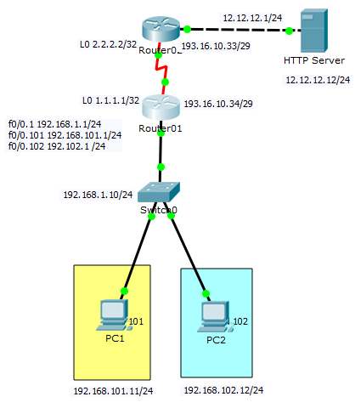

|  |
| --- |
| Router(config)#hostname Router1 |
| Router1(config)#ip cef |
| Router1(config)#no ipv6 cef |
| Router1(config)#no ip domain-lookup |
| Router1(config)#spanning-tree mode pvst |
| Router1(config)#interface loopback0 |
| Router1(config-if)# ip address 1.1.1.1 255.255.255.255 |
| Router1(config-if)#interface fastethernet 0/0 |
| Router1(config-if)#no ip address |
| Router1(config-if)#duplex auto |
| Router1(config-if)#speed auto |
| Router1(config-if)#interface fastethernet 0/0.1 |
| Router1(config-if)#encapsulation dot1q 1 native |
| Router1(config-if)#ip address 192.168.1.1 255.255.255.0 |
| Router1(config-if)#interface fastethernet 0/0.101 |
| Rouer1(config-if)#encapsulation dot1q 101 |
| Rouer1(config-if)#ip address 192.168.101.1 255.255.255.0 |
| Router1(config-if)#ip access-group ALLOW-HTTP in |
| Router1(config-if)#ip access-group ALLOW-VLAN1-HTTP out |
| Router1(config-if)#ip nat inside |
| Router1(config-if)#interface fastethernet 0/0.102 |
| Router1(config-if)#encapsulation dot1q 102 |
| Router1(config-if)#ip address 192.168.102.1 255.255.255.0 |
| Router1(config-if)#ip access-group ALLOW-VLAN2-ICMP out |
| Router1(config-if)#ip nat inside |
| Router1(config-if)#interface fastethernet0/1 |
| Router1(config-if)#no ip address |
| Router1(config-if)#duplex auto |
| Router1(config-if)#speed auto |
| Router1(config-if)#shutdown |
| Router1(config-if)#interface serial 0/0/0 |
| Router1(config-if)#no ip address |
| Router1(config-if)#ip nat outside |
| Router1(config-if)#clock rate 2000000 |
| Router1(config-if)#shutdown |
| Router1(config-if)#interface serial 0/0/1 |
| Router1(config-if)#ip address 193.16.10.34 255.255.255.248 |
| Router1(config-if)#ip nat outside |
| Router1(config-if)#clock rate 2000000 |
| Router1(config-if)#interface vlan1 |
| Router1(config-if)#no ip address |
| Router1(config-if)#shutdown |
| Router1(config-if)#ip nat pool PUBLIC-NAT-POOL 192.16.10.35 193.16.10.36 netmask 255.255.255.248 |
| Router1(config-if)#ip nat inside source list ALLOW-FOR-NAT pool PUBLIC-NAT-POOL |
| Router1(config-if)#ip classless |
| Router1(config-if)#ip route 0.0.0.0 0.0.0.0 193.16.10.33 |
| Router1(config-if)#ip flow-export version 9 |
| Router1(config-if)#ip access list extended ALLOW-VLAN1-HTTP |
| Router1(config-if)#permit tcp any 1922.168.101.0 0.0.0.255 |
| Router1(config-if)#deny ip any any |
| Router1(config-if)#ip access list extended ALLOW-VLAN2-ICMP |
| Router1(config-if)#permit icmp any 192.168.102.0 0.0.0.255 |
| Router1(config-if)#deny ip any any |
| Router1(config-if)#ip access-list extended ALLOW-HTTP-VLAN101 |
| Router1(config-if)#deny ip any any |
| Router1(config-if)#permit tcp 192.168.101.0 0.0.0.255 host 12.12.12.12 eq www |
| Router1(config-if)#ip access list extended ALLOW-ICMP-VLAN102 |
| Router1(config-if)#permit icmp 192.168.102.0 0.0.0.255 any |
| Router1(config-if)#deny ip any any |
| Router1(config-if)#ip access-list standard ALLOW-FOR-NAT |
| Router1(config-if)#permit 192.168.101.0 0.0.0.255 |
| Router1(config-if)#permit 192.160.102.0 0.0.0.255 |
| Router1(config-if)#deny any |
| Router1(config-if)#permit 192.168.1.0 0.0.0.255 |
| Router1(config-if)#line console 0 |
| Router1(config-line)#exect-timeout 0 0 |
| Router1(config-line)#password cisco |
| Router1(config-line)#logging synchronous |
| Router1(config-line)#login |
| Router1(config)#line aux 0 |
| Router1(config)#line vty 0 4 |
| Router1(config)#exec-timeout 0 0 |
| Router1(config)#password cisco |
| Router1(config)#logging synchronous |
| Router1(config)#login |
| Router1(config)#exit |

*(10 points)*

1. **Extended ACLs and Extended Named ACLs (NOTE: how, where and why you applying these…)**

Extended is near the source.

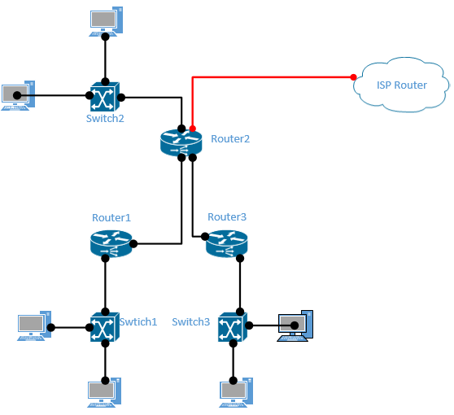

*(10 points)*

1. **NAT/PAT (NOTE: Make sure you show a configuration with only NAT, then PAT...remember there are multiple ways to configure PAT.)**

Network Address Translation (NAT) and Port Address Translation (PAT) both map IP addresses on an internal network to IP addresses on an external network. Which method of address translation you use depends on the types of networks that you are translating and the number of available IP addresses that you have. PAT attempts to use the original source port number of the internal host to form a unique, registered IP address and port number combination. NAT and PAT use at least one IP address and that PAT is also referred to as NAT overloading because it uses one IP address for all clients to multiple ports, whereas standard NAT uses a one-to-one IP address relationship per client.

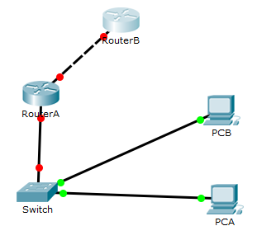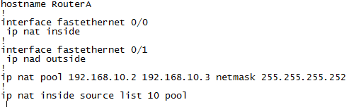

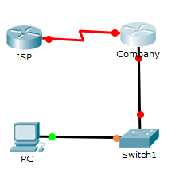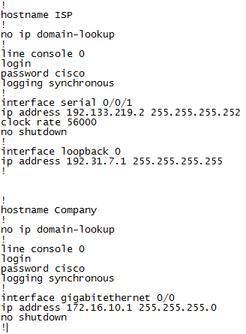

*(10 points)*

1. **DHCP Server and client (NOTE: You should have a DHCP Server for a local and remote network.)**

Dynamic Host Configuration Protocol (DHCP) is a uniform networking protocol used on IP networks to dynamically issue the network configuration parameters.

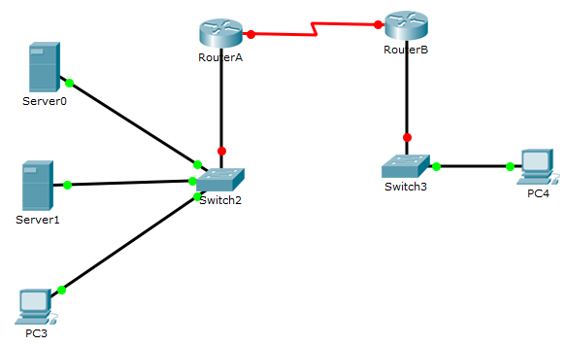

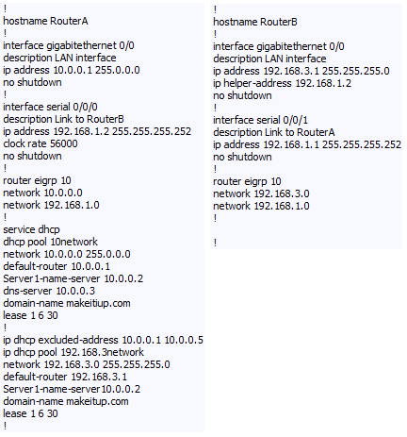*(10 points)*

1. **PPP, PPP PAP and PPP CHAP (NOTE: you may either provide a topology that utilizes both: PPP PAP and CHAP or create two separate topologies.)**

PPP (Point-to-Point Protocol) is a protocol for communication between two computers using a serial interface, typically a personal computer connected by phone line to a server. Challenge-Handshake Authentication Protocol (CHAP) authenticates a user or network host to an authenticating device. CHAP offers protection against attacks by the peer through the use of an incrementally changing identifier and of a variable challenge-value. CHAP requires that both the client and server know the plaintext of the secret, although it is never sent over the network.

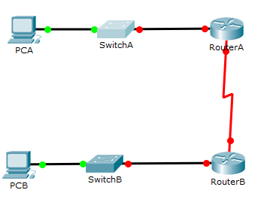

|  |  |
| --- | --- |
| Router>enable | Moves to privileged mode |
| Router#configure terminal | Moves to global configuration mode |
| Router(config)#hostname RouterA | Changes name of router to RouterA |
| RouterA(config)# username Gerard password Taliercio | Sets the local username and password for PPP authentication of the PPP peer. |
| RouterA(config)#interface serial 0/0/0 | Enters the configuration for int s0/0/0 |
| RouterA(config-if)# ip address 172.16.20.1 255.255.255.252 | Sets the IP address and mask |
| RouterA(config-if)# clock rate 56000 | Set the clock rate to the data communications equipment (DCE) side. |
| RouterA(config-if)#encapsulation PPP | Turns on PPP encapsulation |
| RouterA(config-if)#ppp authentication chap | Turns on CHAP authentication |
| RouterA(config-if)#no shutdown | Turns the interface on |
| ############################## | ############################## |
| Router>enable | Moves to privileged mode |
| Router#configure terminal | Moves to global configuration mode |
| Router(config)#hostname RouterB | Changes name of router to RouterB |
| RouterB(config)# username mister password awesome | Sets the local username and password for PPP authentication of the PPP peer. |
| RouterB(config)#interface serial 0/0/1 | Enters the configuration for int s0/0/1 |
| RouterB(config-if)# ip address 172.16.20.2 255.255.255.252 | Sets the IP address and mask. |
| RouterB(config-if)#encapsulation ppp | Turns the PPP encapsulation on. |
| RouterB(config-if)#encapsulation chap | Turns the CHAP authentication on. |
| RouterB(config-if)#no shutdown | Turns the interface on. |

*(10 points)*

1. **Frame Relay (NOTE: You should learn your DLCI numbers automatically from the Frame Relay Switch. Your LMI-Type should be altered from the default LMI-Type. You do NOT need to show a configuration with sub-interfaces for this semester.)**

Network providers commonly use frame relay for voice and data as an encapsulation technique, used between local area networks (LANs) over a wide area network (WAN). Each end-user gets a private line (or leased line) to a Frame Relay node. The frame relay network handles the transmission over a frequently changing path transparent to all end-user extensively used WAN protocols. The easiness of configuring user equipment in a frame relay network offers another reason for frame relay's popularity.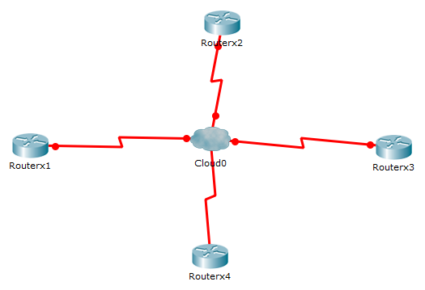

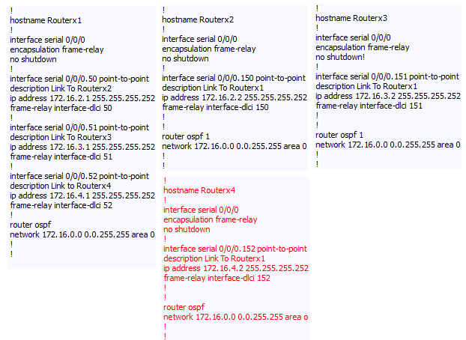 *(10 points)*

1. **Descriptions and Messages (NOTE: Interface descriptions, Message of the Day, Login Messages, etc…)**

|  |  |
| --- | --- |
| Router(config)#banner motd # this is our final project. #  Router(config)# | The # is a delimiting character which must surround the message. |
| Router(config)##banner login #you do not belong here#  Router(config)# | To display this message you must use the delimiting character to encompass the message you want displayed. |

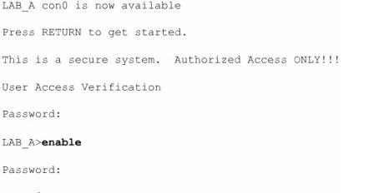*(10 points)*

1. **CDP**

Cisco Discovery Protocol (CTP) is a proprietary protocol designed by cisco that is supposed to help administrators gather information about the locally attached devices and the remotely attached devices. With the use of cisco discovery protocol the administrator can collect information regarding the hardware and protocol information of neighboring devices. This can be helpful when someone needs to troubleshoot the network. Cisco Discovery Protocol message are generated every 60 seconds as multicast messages on each of the active interfaces.

|  |  |
| --- | --- |
| **Router#show cdp** | Displays global CDP information (such as timers) |
| **Router#show cdp neighbors** | Displays information about neighbors |
| **Router#show cdp neighbors detail** | Displays more detail about the neighbor device |
| **Router#show cdp entry word** | Displays information about the device named word |
| **Router#show cdp entry \*** | Displays information about all devices |
| **Router#show cdp interface** | Displays information about interfaces that have CDP running |
| **Router#show cdp interface x** | Displays information about specific interface x running CDP |
| **Router#show cdp traffic** | Displays traffic information—packets in/out/version |
| **Router(config)#cdp holdtime x** | Changes the length of time to keep CDP packets |
| **Router(config)#cdp timer x** | Changes how often CDP updates are sent |
| **Router(config)#cdp run** | Enables CDP globally (on by default) |
| **Router(config)#no cdp run** | Turns off CDP globally |
| **Router(config-if)#cdp enable** | Enables CDP on a specific interface |
| **Router(config-if)#cdp enable** | Enables CDP on a specific interface |
| **Router(config-if)#no cdp enable** | Turns off CDP on a specific interface |
| **Router#clear cdp counters** | Resets traffic counters to 0 |
| **Router#clear cdp table** | Deletes the CDP table |
| **Router#debug cdp adjacency** | Monitors CDP neighbor information |
| **Router#debug cdp events** | Monitors all CDP events |
| **Router#debug cdp ip** | Monitors CDP events specifically for IP |
| **Router#debug cdp packets** | Monitors CDP packet-related information |

*(10 points)*

1. **IPv6 (Please NOTE: You should still write a paragraph, create a topology, develop a configuration, display the show commands and provide a test case.)**

IPv6 is basically the expansion of internet address directories. As of now there are 4.3 billion internet protocols which are unique. IPv6 assigns internet addresses in a different way where the number if internet protocols can be as big as 340 trillion, trillion, trillion. With the growing number of mobile phones, laptops, online gamers, and anything else you can think of we are already at the point of using all 4.3 billion internet protocol addresses.

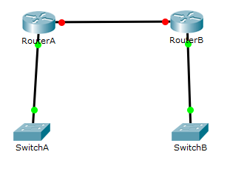

|  |  |
| --- | --- |
| Router>enable | Moves to privileged mode |
| Router#configure terminal | Moves to global configuration mode |
| Router(config)#hostname RouterA | Changes the router name to RouterA |
| RouterA(config)#ipv6 unicast-routing | Enables the forwarding of IPv6 unicast data-grams globally on the router. |
| RouterA(config)# interface fastethernet0/0 | Enters the configuration mode |
| RouterA(config)-if)#ipv6 enable | Automatically configures an IPv6 link-local address on the interface and enables IPv6 processing on the interface. |
| RouterA(config-if)#ipv6 address 2001:db8:c18:2::/64 eui-64 | Configures a global IPv6 address with an interface identifier in the low-order 64 bits of the IPv6 address |
| RouterA(config-if)#ipv6 rip tower enable | Creates the RIPng process named tower and enables RIPng on the interface |
| RouterA(config-if)#no shutdown | Turns the interface on |
| RouterA(config-if)#interface fastethernet0/1 | Enters the configuration mode |
| RouterA(config-if)#ipv6 enable | Automatically configures an IPv6 link-local address on the interface and enables IPv6 processing on the interface. |
| RouterA(config-if)#ipv6 address 2001:db8:c18:1::64 eui-64 | Configures a global IPv6 address with an interface identifier in the low-order 64 bits of the IPv6 address. |
| RouterA(config-if)#ipv6 rip tower enable | Creates the RIPng process named tower and enables RIPng on the interface |
| RouterA(config-if)#no shutdown | Turns the interface on |

|  |  |
| --- | --- |
| Router>enable | Moves to privileged mode |
| Router#configure terminal | Moves to global configuration mode |
| Router(config)#hostname RouterB | Changes the router name to RouterA |
| RouterB(config)#ipv6 unicast-routing | Enables the forwarding of IPv6 unicast data-grams globally on the router. |
| RouterB(config)# interface fastethernet0/0 | Enters the configuration mode |
| RouterB(config)-if)#ipv6 enable | Automatically configures an IPv6 link-local address on the interface and enables IPv6 processing on the interface. |
| RouterB(config-if)#ipv6 address 2001:db8:c18:2::/64 eui-64 | Configures a global IPv6 address with an interface identifier in the low-order 64 bits of the IPv6 address |
| RouterB(config-if)#ipv6 rip tower enable | Creates the RIPng process named tower and enables RIPng on the interface |
| RouterB(config-if)#no shutdown | Turns the interface on |
| RouterB(config-if)#interface fastethernet0/1 | Enters the configuration mode |
| RouterB(config-if)#ipv6 enable | Automatically configures an IPv6 link-local address on the interface and enables IPv6 processing on the interface. |
| RouterB(config-if)#ipv6 address 2001:db8:c18:3::64 eui-64 | Configures a global IPv6 address with an interface identifier in the low-order 64 bits of the IPv6 address. |
| RouterB(config-if)#ipv6 rip tower enable | Creates the RIPng process named tower and enables RIPng on the interface |
| RouterB(config-if)#no shutdown | Turns the interface on |

Sources:

* CCNA Routing and Switching Portable Command Guide Third Edition
* [www.cisco.com](http://www.cisco.com)
* Cisco CCNA Routing and Switching 200-120 Official Cert Guide Library - 2013